Day-2 Deliverable
1. Hero Section Copy
Prompt
You are a senior UX copywriter for a modern SaaS product.
Task:
Generate hero section copy for a landing page.
Constraints:
- One headline (maximum 8 words)
- One subheading (maximum 18 words)
- Professional and confident tone
- No emojis
- No marketing buzzwords
Output format:
Headline:
Subheading:
Output
Headline:
Build interfaces users actually understand
Subheading:
Design, test, and refine product experiences with clarity and precision.
2. Features Section Copy
Prompt
You are a professional UX writer working on a SaaS landing page.
Task:
Generate feature descriptions for the features section.
Constraints:
- Provide exactly 3 features
- Each feature must have a title and one short description
- Clear, concise, and user-focused language
- Avoid technical jargon
Output format:
Feature 1:
Feature 2:
Feature 3:
Output
Feature 1:
Clear Navigation
Find what you need quickly with simple paths and predictable layouts.
Feature 2:
Consistent Language
Use familiar terms and messages so users always know what to expect.
Feature 3:
Actionable Feedback
Show clear responses to user actions, reducing confusion and mistakes.
3. Footer Helper Text
Prompt
You are a UX content writer creating footer text for a website.
Task:
Generate footer helper text.
Constraints:
- One short sentence
- Friendly but professional tone
- Should build trust
Output format:
Footer Text:
Output
Footer Text:
Built with care to keep your experience reliable, secure, and transparent.
4. Button Text Variants
Prompt
You are designing call-to-action buttons for a web application.
Task:
Generate 3 button text options for a primary action
Constraints:
- Each option must be 2–3 words
- Clear and action-oriented
- No emojis
Output format:
Option 1:
Option 2:
Option 3:
Output
Option 1:
Get Started
Option 2:
Start Free
Option 3:
Begin Now
5. Empty State Message
Prompt
You are a UX writer designing an empty state message.
Task:
Generate an empty state message for when no data is available.
Constraints:
- One headline
- One supporting sentence
- Reassuring and helpful tone
Output format:
Headline:
Message:
Output
Headline:
Nothing here yet
Message:
There’s no data to show right now—once something is added, it will appear here automatically.
6. Form Error Message
Prompt
You are writing form validation messages.
Task:
Generate an error message for an invalid password input.
Constraints:
- One sentence
- Clear and polite
- Do not blame the user
Output format:
Error Message:
Output
Error Message:
Please enter a valid password that meets the required criteria.
Summary
These samples demonstrate:
- Clear role-based prompting
- Controlled tone and length
- Consistent UX copy generation
- Reusable prompt patterns for production systems

This approach enables frontend engineers to automate UI text creation
while maintaining quality and consistency.
Task 2:
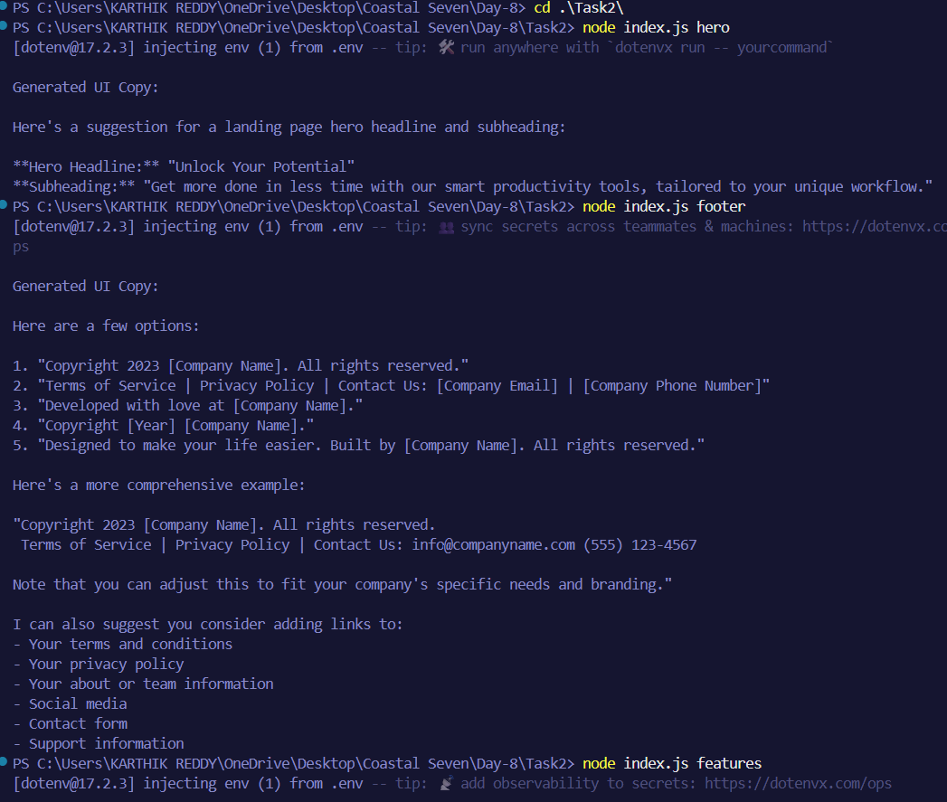
Task 3:
